WACSP - Wisconsin Association of Central Service/Sterile Processing Professionals
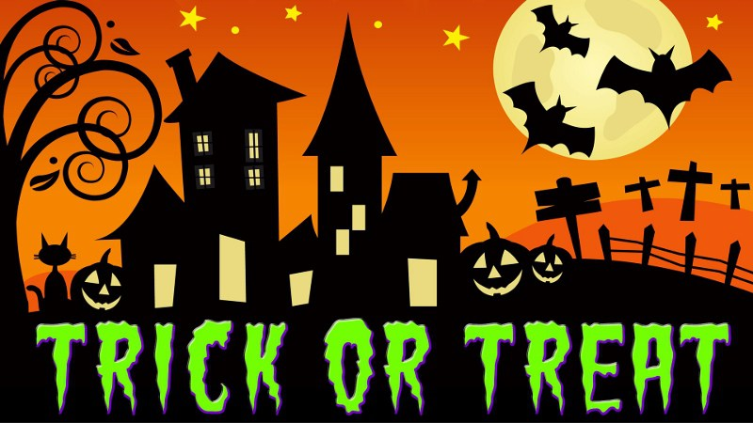

Dear Company Representative,

The Wisconsin Association of Central Service/Sterile Processing Professionals (WACSP) is sponsoring their 32nd annual 2–day Seminar on Oct. 18-19th 2018, at the Chula Vista Resort & Waterpark – Wisconsin Dells.
Invitations announcing the seminar will be sent to all members of WACSP as well as non-members throughout the state.

We invite you to participate in the Product Fair to be held on Friday, October 19th from 10:30 AM to 12:00 PM. The Product Fair is designed to compliment the educational meeting by providing access to the latest developments in medical devices and services available to health care institutions. This exchange is always beneficial to all.

Each Product Fair participant’s booth will have an 8’ table for table top display. Location of booth(s) will be assigned. Requests for specific areas will be honored on first come, first serve basis. WACSP reserves the right to adjust vendor booth locations based on proximity of competitive firms, date of receipt and number of areas requested.

The theme for this year’s conference is “Halloween”, a costume theme. 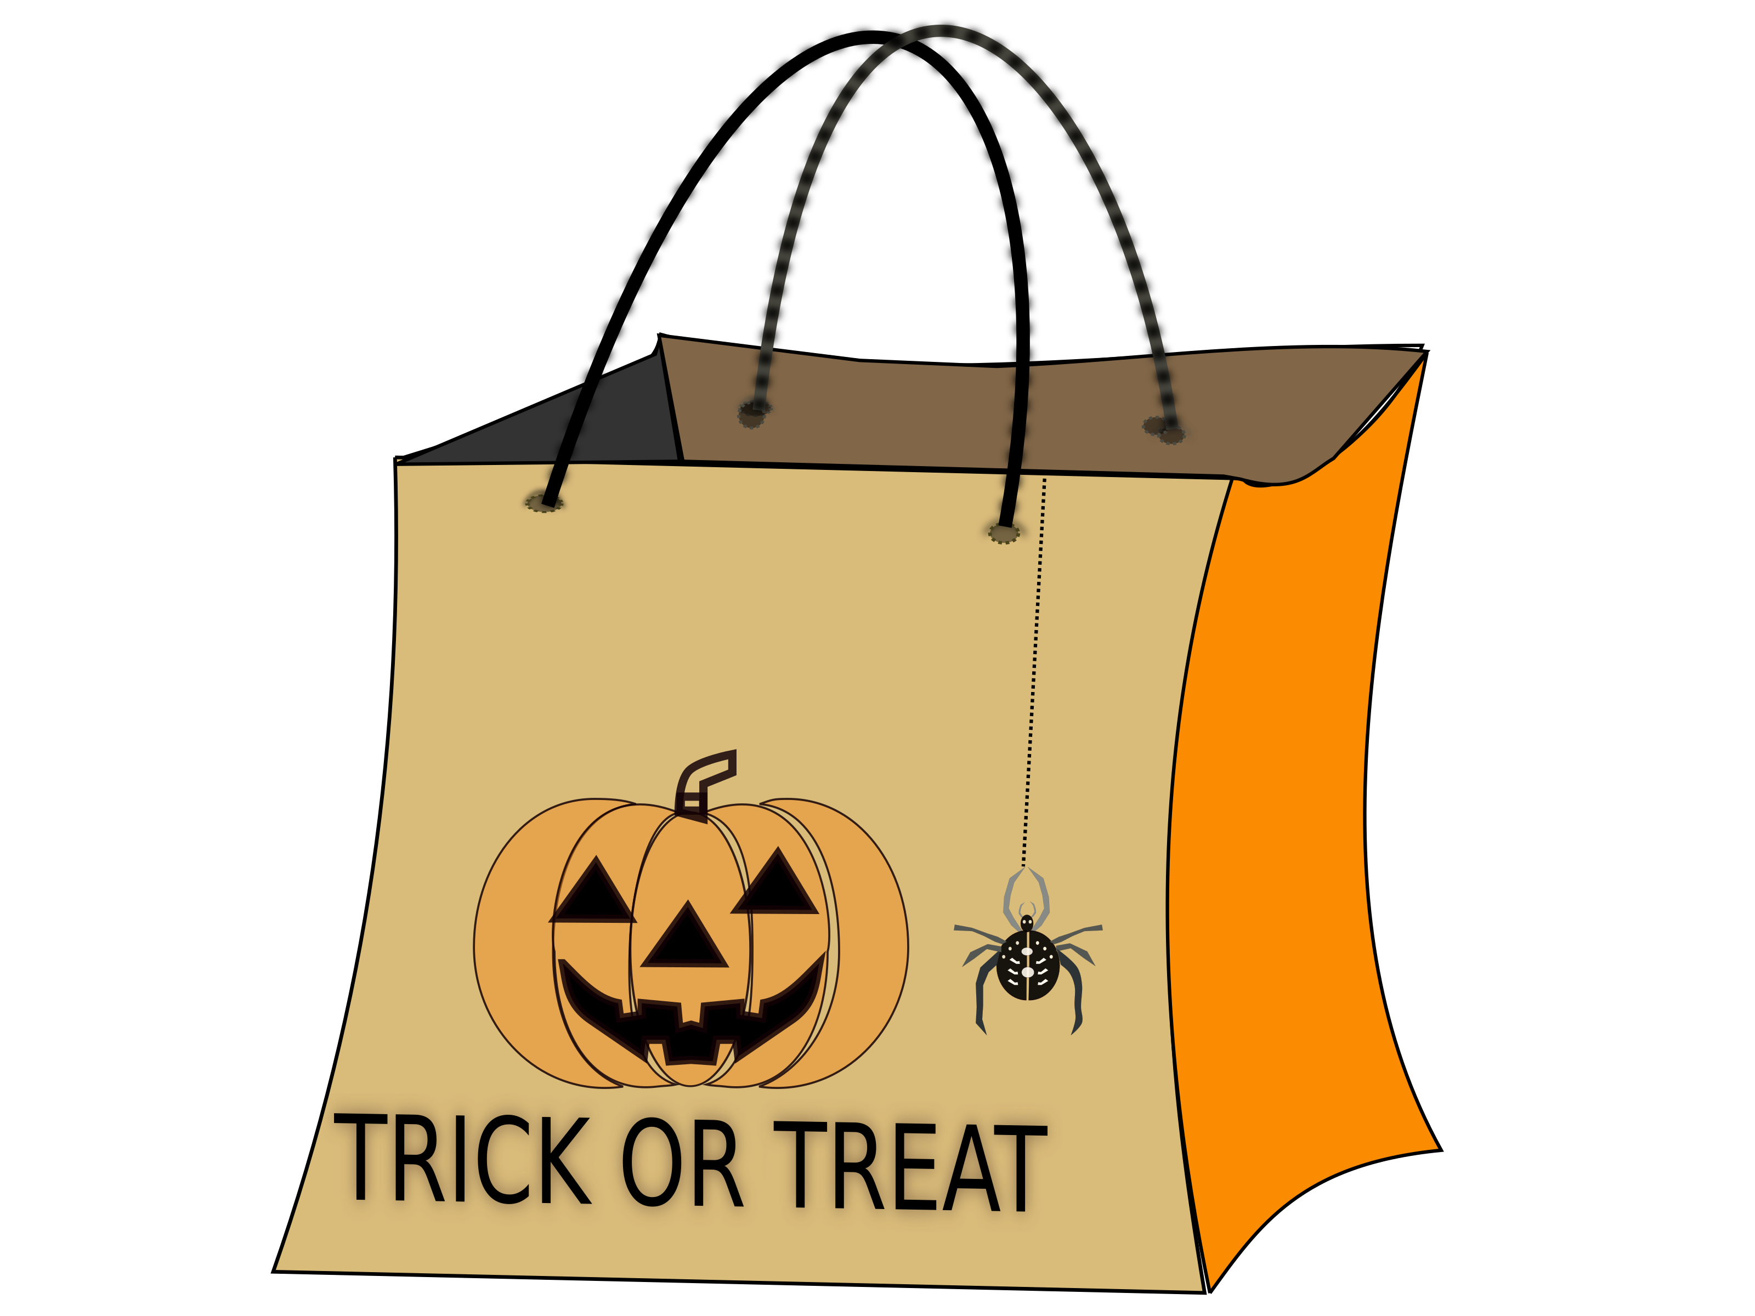
You may wish to include this theme in your booth and have some fun with it – ie: bring candy for “Trick-or-Treating”. Drawings for door prizes will be conducted periodically throughout the Product Fair time. We are doing this to encourage attendees to remain in the area to interact with vendors. WACSP would welcome contributions of prizes from companies. These can be brought to the Product Fair on Friday, October 19th.

The fee for each booth is $350 and we require application and payment to be received by October 12th, 2017. This includes lunch for up to two representatives.

- If you wish to participate please complete the enclosed form. Applications will not be processed nor space assigned without receipt of the required fee.
-or-
- You may go to our website, where you will find the Vendor Application. You can pay there with a credit card: http://wacsp.org

We welcome vendors who are willing to sponsor speakers. Those vendors who sponsor speakers will be given their Product Fair booth at no charge and can attend the educational sessions free of charge. WACSP is soliciting participation in this seminar from throughout the state. Please contact your sales representatives that serve the entire state.

*We will provide sign in sheets for each booth so that attendees can provide their contact information if they desire to be contacted or receive additional information.
Seminar and Product Fair Vendor Booth Application Form
Friday, October 19th, 2017
10:30 AM – 12:00 PM

Company ____________________________________________________________________

Representative Name: __________________________________________________________
Address _________________________________________________________
City/State/Zip Code________________________________________________
Phone ___________________________________________________________
E-mail address _________________________________________

Will you be attending the luncheon to follow the Vendor Fair? ____ yes ____ no
**If yes, # of people attending luncheon - Check one: ____ 1 person ____ 2 people

Important note: WACSP must know the definite number of people attending the luncheon.

Fee per booth is $350:

Enclosed is a fee of $_________ to reserve__________ # of booth(s).

Please mail WACSP vendor booth application form and check, payable to:
WACSP before Oct 12th 2018 to the following address:
- Cyndi Lee 2012 Grandview Ct Waukesha, WI 53188

-or-

Go to our Website where you can register & pay with a credit card: http://wacsp.org

The exhibitor agrees to keep and protect the WACSP forever harmless from any damage or charges imposed for any violation of any law ordinance. The exhibitor shall at all times protect, indemnify and hold harmless the WACSP and the hotel in which the exhibit area is located, from any and all losses, costs, damages, liability or expense from or out of any accident or other occurrence to anyone.

___I am interested in attending education sessions. Please send brochure and application form.

_____________________________ ______________________
Signature Date

Thank you for your past and continuing support of the Wisconsin Association of Central Service/Sterile Processing Professionals! Your support allows us to provide excellent educational and networking seminars for our members.

